Object Oriented Programming

**Homework 3 : 10 points, Deadline is on Saturday, November 28,2020 Before 11:59 PM.**

* **Please submit a GitHub link in Blackboard (Write your names in Blackboard and GitHub).**
* **Each 2 students should work in a group.**

1. **Write a java code that uses Inheritance or Polymorphism.**
   * **Comments (1 point)**
   * **OOP (3 point)**
   * **Creativity in your Java Code. ( 1 point)**
2. **Suppose that statement2 causes an exception in the following statement: (1,5 points)**

try { statement1; statement2; statement3;

}

catch (Exception1 ex1) { } finally {

statement4;

}

statement5;

Answer the following questions:

* If no exception occurs, will statement4 be executed, and will statement5 be executed?

1. statement4 (No/**Yes**) **(0.25 point)**
2. statement5 (No/**Yes**) **(0.25 point)**

* If the exception is of type Exception1, will statement4 be executed, and will statement5 be executed?

1. statement4 (No/**Yes**) **(0.25 point)**
2. statement5 (No/**Yes**) **(0.25 point)**

* If the exception is not of type Exception1, will statement4 be executed, and will be statement5 executed?

1. statement4 (No/**Yes**) **(0.25 point)**
2. statement5 (**No**/Yes) **(0.25 point)**

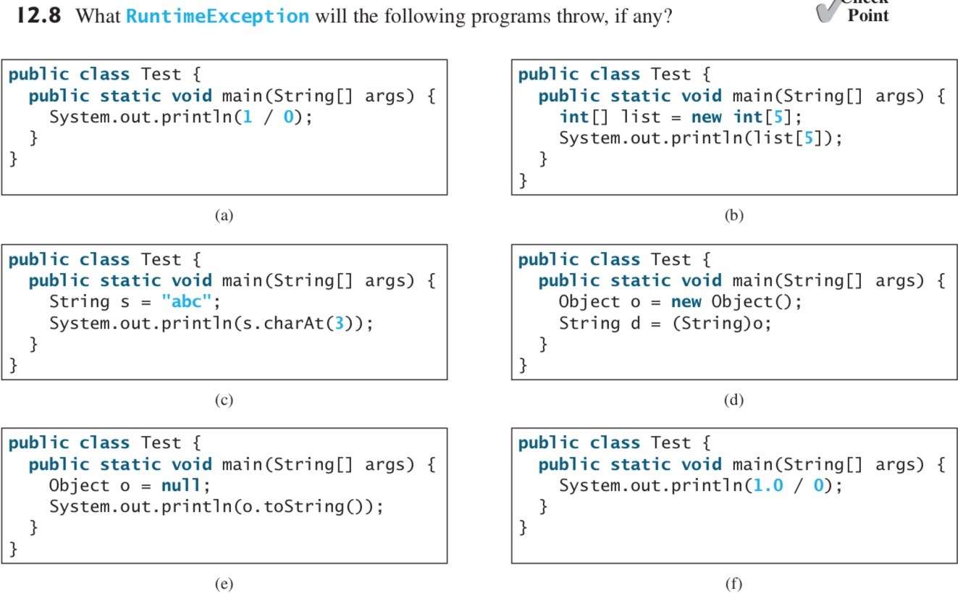

**Total : 3.5 points**

* (**0.25 point)** for each program.
* (**2 points** to use try-catch in two programs that throw an exception)